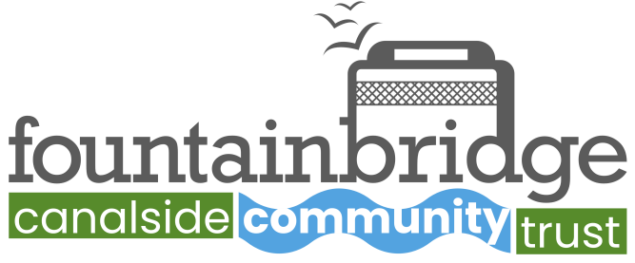

Fountainbridge Canalside Community Trust

Strategic Plan

Date: 21st January 2025
Reviewed 20th May 2026

Executive Summary

Fountainbridge Canalside Community Trust works with others to create and manage new projects. We support and strengthen opportunities for economic, environmental and cultural activity that benefits the community, and will promote social inclusion, sustainability and well-being. We want to create a community-led organisation that uses a combination of enterprise and creativity to improve the quality of life for people living, and coming to live, in our area.

This plan has been produced in order to support fundraising for a new canal boat to replace Lochrin Belle, FCCT’s main boat for hire. Lochrin Belle is now over 15 years old, and although still a viable hire boat, is increasingly costly, requiring maintenance and refurbishment on a regular basis.
It is also powered by diesel, and in 2023, the Board of FCCT agreed to replace the boat with one that is propelled by electricity, as a contribution towards achieving net zero and preserving the canal environment.
Background

Fountainbridge Canalside Community Trust was set up in November 2021 through a merger of Re-Union Canal Boats Ltd and Fountainbridge Canalside Initiative (FCI). The two groups had been planning a merger since March 2020, when the Covid pandemic hit. Re-Union’s Development Manager supported the Board to investigate the feasibility of setting up a new Development Trust for the area around Fountainbridge and the Union Canal.

Community Development Trusts are community-owned and led organisations, working to combine community-led action with an enterprising approach to address and tackle local needs and issues. The aim of a development trust is to create social, economic and environmental renewal in a defined geographical area, as well as to contribute to the local economy.

The group concluded that we could achieve more by working together. At Re-Union’s AGM, the Members voted to change the name of the organisation and adopt a new constitution, based on a recommended model memorandum and articles suitable for organisations operating as local Community Development Trusts. Through this arrangement we took the legacy and assets of Re-Union forward in the work that we now do, while combining them with FCI’s unique community voice.

Re-Union Canal Boats was established in 2004 to work with canalside communities near the Union Canal. Re-Union supported and encouraged communities to engage positively with the canal, and promoted its heritage, environment and amenity, with a view to encouraging more local people to use the canal to their benefit. The organisation delivered a range of projects around volunteering, employability, environmental improvement and health & well-being, as well organising the popular Edinburgh Canal Festival.
Fountainbridge Canalside Initiative started in 2011 as a group of community activists and local groups who lobbied local developers and the Council for the creation of a mixed, sustainable neighbourhood to be created at Fountainbridge. The group successfully supported temporary activities like the Grove and the Forge on the empty site, actively consulted with the community and managed to get agreement by the Council on affordable housing; low carbon heating; social enterprise units and a Green Plan for the area.

Since 2022, the Board of FCCT has been working with an electric boat sub-committee composed of current volunteers, Board members with knowledge of boating and canal issues, and external supporters who have a long established involvement in canal and boating issues and who have design and other expertise to offer. This group has been supported by a Greenshoots grant from the Development Trusts Association for Scotland.

The total project cost is £240,000 of which £84,000 is requested as a loan repaid through sales income.

Current projects and activities include:

Running 3 canal boats
Weekly Canalside Wellbeing Walk
Weekly Greenspace Group
Volunteering
Community Events
Edinburgh Canal festival, Picnic in Harrison Park and Raft Race
Working with Developers at Fountainbridge
Development of a canal and social enterprise centre based in new workshop units available for hire to the public.

We are starting and will continue to add to our annual calendar of events.

Spring Greenspace Event
Canal Festival (June)
Picnic in the Park (July)
Festival Events on board (August)
Raft race (August)
Bat walks (Sept)
Pumpkins in the Park (October)
Flotilla of Lights (November)
Christmas Canalside Market (December)

Boat hire activities
FCCT currently owns 3 boats, designed to address 3 different markets.
Lochrin Belle.
Launched in May 2008, the ‘big boat’ was built through a National Lottery grant and involved practical input from a range of volunteers into fitting out the boat and getting it ready.
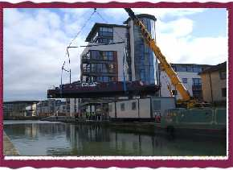
Lochrin Belle (LB) is a 60 foot widebeam boat, which is the maximum size of boat that can sail on the Union Canal. It is hired out to private individuals, community groups and to a number of local businesses who organise their own sales function and hire the boat from FCCT. It has also been used extensively for training, to run project activities and provide volunteering opportunities.
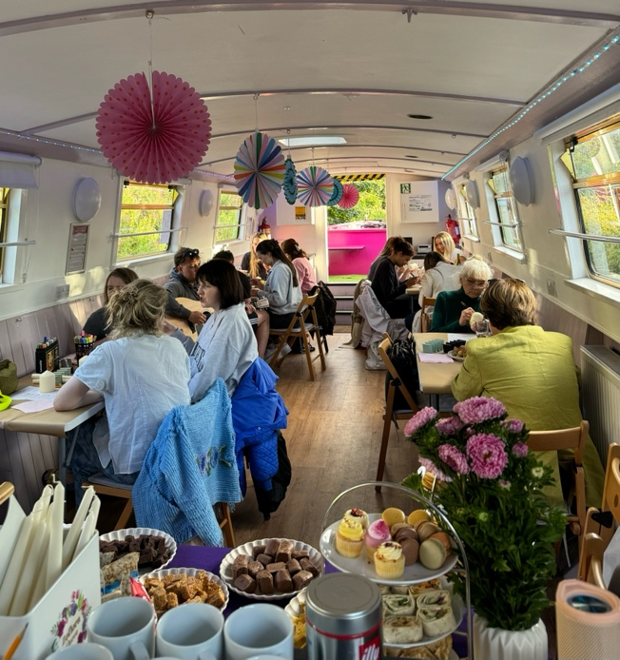
Since its launch, LB has been hired by private individuals, local community groups, local businesses and has supported many volunteers. Specifically, from April 2023 to March 2024, Lochrin Belle completed 262 trips playing host to over 4,000 passengers. This was made up of 25 funded community trips (free to participants), 23 community group hires, 76 private hire trips, 91 trips with partner organisations, 18 static events and 29 volunteering and training sessions.
Since 2017 (when Re-Union introduced Xero accounting software) LB has generated just under £400,000 in sales for the organisation. This therefore has been an incredibly important source of funds to support FCCT’s community aims and objectives.
LB is inspected and certificated by the Marine & Coastguard Agency on an anuual basis. It is allowed to take up to 32 people on board, including crew. The boat has to be driven by a skipper who holds a Boatmasters Licence.
FCCT has an active training and volunteering programme and has created a pathway to employment – for those looking for employment or a career change. The pathway starts with volunteers training as crew members, then gaining an RYA Helmsman qualification and finally an MCA Boatmaster Licence, which then allows them to be employed by FCCT as a Skipper on a sessional or freelance basis. We are currently supporting 1 to 2 people each year in completing this journey and becoming a Skipper.
Waterwitch
This is an old narrowboat, much smaller than Lochrin Belle, which is licensed to take up to 12 passengers and crew only.
FCCT acquired Waterwitch in November 2023 privately through canal contacts, and funded it by disposal of the sale of shares Re-Union had held in Capercaillie Cruisers Ltd.
Waterwitch has been extensively renovated under FCCT’s ownership, as it was set up as a live aboard boat not a hire boat. It does not require a qualified Boatmaster to be in charge of the boat, and this has extended the range of responsibilities that volunteers can take up within the boat hire activities. The work and development of the boat overall has been a real volunteer project, with involvement at every stage.
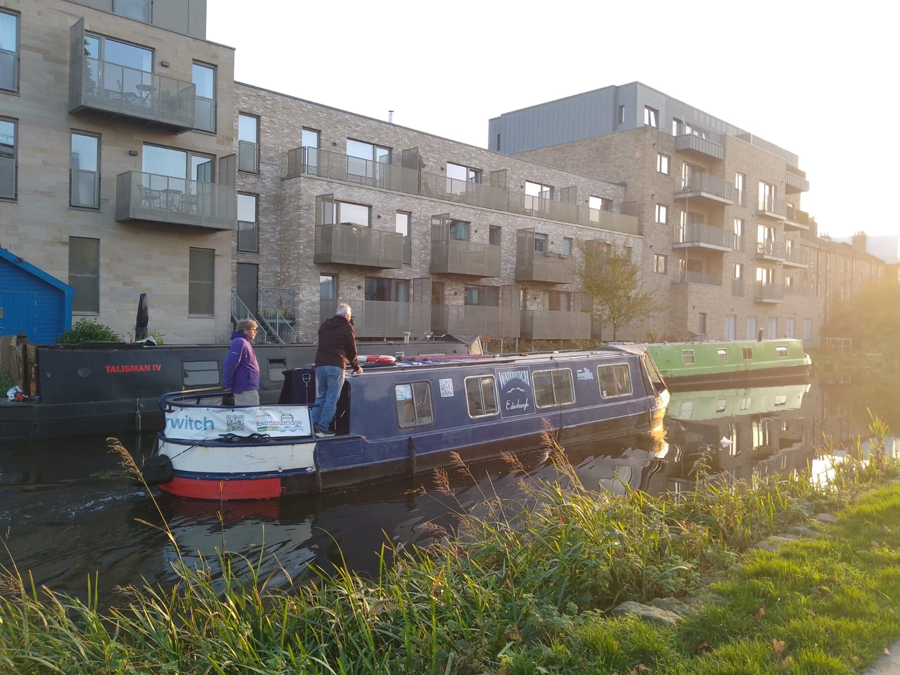
In its first season in 2024, it generated almost £8,000 in sales, primarily through an agreement with the It Is On voucher scheme. This has been renewed for the 2026 season.
Waterwitch would benefit from being converted to electric propulsion, and plans and costings have been drawn up. The decision however has been to not include Waterwitch in this proposal, as we want to see how sales expand before fully committing to the boat. Any electrification would therefore have to generate a return in 1 or 2 seasons.
It is the nature of canal boats however that values do not significantly deteriorate with age, and FCCT’s boat advisor and valuer has said that the boat would fetch more on the open market than FCCT paid for it, (due to our volunteers’ work and renovations) should it be sold.
Kingfisher
Kingfisher is a purely electric boat, purchased new with CCL funds, in December 2023. It is more like an inland rescue boat. It has been used to offer short trips at the canal festival, and day hire for small groups of up to 8 people, such as families, to take a short trip on the canal.
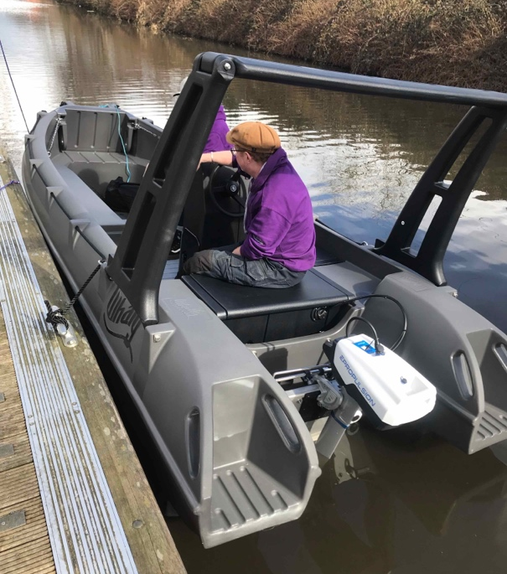
Sales in its first year were low, due to the need to familiarise volunteers with the electric propulsion system and ensure volunteers knew how to manage the boat’s power requirements. As a training project for volunteers, it has been excellent however and is now almost completely managed by a pool of committed volunteers.
Boat asset values
As of 1.12.2024, the 3 boats are sitting in FCCT’s balance sheet at NBV:
Lochrin Belle was fully depreciated in July 2024 apart from a new kitchen, currently valued at £1066, depreciation at 20% straight line. The boat itself was depreciated over 15 years.
Waterwitch valued at a NBV of £15,187, depreciation rate of 10% straight line.
Kingfisher valued at £8,775, depreciation at 5% straight line, based on the manufacturers warranty of 20 years.
In addition, FCCT owns a small workboat for weed clearing and other canal up work. It is currently valued at NBV £1,642. Generally, this boat is on loan to other canal groups at no cost other than insurance.
Lochrin Belle valuation
FCCT has the services of a boat sales broker on its ‘electric boat sub group’. He has valued Lochrin Belle sold as a live aboard boat as being worth £60,000 in the current market.
Development
Covid had a huge impact on Re-Union Canal Boats. Sales dried up overnight. Other funds became available however to keep the organisation going, and the Board took the opportunity of having no operational duties and responsibilities in order to re-design Re-Union, and subsequently create FCCT, from scratch, with the involvement of Fountainbridge Community Initiative. ‘Re-Union Canal boats Ltd was turned into ‘Fountainbridge Canalside Community Trust in November 2021. The first AGM of FCCT was held in October 2022.
Part of this review process included looking in more detail at the idea of electrifying the main hire boat Lochrin Belle. For a range of reasons, it was decided to replace LB with a re-designed boat built with electric propulsion in mind. An ‘electric boat sub-committee’ was set up with members from the board, staff, volunteers and external support with boat design and electrification experience. Members went to visit other canal boat groups across the UK who had electric boats, and had contact with a lot more to get a sense of the pros and cons of electrification. The sub-committee was significantly aided by having an expert involved from the Inland Waterways Association’s Sustainability Group who had experience in canal boat electrification projects. The group received funds through DTAS’s Greenshoots funding programme to support innovation in social enterprise.
FCCT staff then facilitated a process with LB customers, volunteers and skippers to find out what factors needed to be kept in mind when designing a new boat. All aspects of the customer feedback and crew experience on LB was examined, and a list drawn up of essential and desired characteristics for the new boat.
Staff contacted a large number of previous customers about their suggestions for improvements, and this feedback has been incorporated into the brief.
One of FCCT long standing partners (The Sorted Project) had been inspired by Re-Union’s example to build a boat purely for volunteering training and support. There were features of the design of this boat that were incorporated into the design of FCCT’s new boat.
Following a competitive tendering process with the main canal boat builders (all based in England) the board decided to commission Crafted Boats Ltd to build and fit out the boat hull. They had built the Sorted Project’s boat, and staff and volunteers felt they were the most responsive builder, and had proven themselves to be able to deliver a boat to a high specification suitable for the Union Canal in Scotland.
In December 2024, FCCT paid a £1,000 deposit to Crafted Boats to start the detailed design process and secure a build slot from August 2025. Details of the process and confirmation of dates will be done in a face to face meeting with the boat builder on 31st January 2025.
Projections
Sales and cost projections for the first two years following the new boat launch in February 2027 are available. Overall FCCT projects are created annually in January and approved by the Board in March/April.

Appendix 1 Company Information
Organisation Name: Fountainbridge Canalside Community Trust
Legal Status: Charity & Company limited by guarantee
Company Number: SC265866
Scottish Charity No: SC035342
Date of Incorporation: 1 April 2004 (As Re-Union Canal Boats Ltd)
Registered Office: c/o Scottish Canals Office
23 Lower Gilmore Place
EDINBURGH EH3 9NY
Legal Advisers:
Bankers: RBS
Accountants: AAB Group
Company website: www.fcct.scot

Board members

At least 75% of the Directors must live, volunteer or work in the area of benefit i.e. Fountainbridge.
Fiona Stephen
Gerry Baker
Helen Denny(Chair)
Jack Marshall (Treasurer)
Melissa Highton
Richard Allen (Vice Chair)
Sheila Durie
Sheila McMillan
Simon Braunholtz
Lorraine Hughes
Catherine Moar
Natalie McLachlan
Staff and premises
General Manager
Operations and finance Officer
Volunteer Development Officer
Marketing & Events Officer
Community Navigator
Admin Assistant

FCCT is currently based in the Scottish Canals Office at Edinburgh Quay. We have a mutually beneficial arrangement with Scottish Canals, where we use the space in return for opening up the office for boaters, contractors and public enquiries, as well as operating the Leamington Liftbridge to allow boaters (particularly those on holiday hireboats) to bring their boats through the canal basin for mooring or using the facilities.
The lease of 2 canalside units in the New Fountainbridge development are currently being negotiated and fitted out.
Vision, Mission and Aims of FCCT
The Union Canal is a vital and important link which provides the opportunity to embrace and enhance links with the rich cultural history of Fountainbridge. It allows valuable biologically diverse corridors into the city and provides an attractive and sustainable space for recreation and leisure. FCCT will ensure that the developments by the canalside are enriched by releasing the benefits and resources of the Union Canal.
FCCT will focus on working with others to create and manage new projects. It will support and strengthen opportunities for economic, environmental and cultural activity that benefit the community, and will promote social inclusion, sustainability and well-being.
FCCT’s main aims are to:
- Enable and encourage local groups to include the canal in any social, cultural, recreational and economic regeneration plans
- Encourage the development of bio-diverse corridors into any developments and greening towpath areas and public spaces connected to the canal, and ensure implementation of the Fountainbridge Green Plan
- Use the unique asset of Re-Union canal boats to provide opportunities for training and education and for recreational use by visitors and local people
- Stimulate the development of social enterprises in the area
- Develop a voice for canalside communities in order that a constructive dialogue and commitment is developed with funders, investors and stakeholders.
Objects of the organisation (from M&As)
Objects

4 The company has been formed to benefit principally those living within
the Fountainbridge area in Edinburgh and the areas closely adjacent to the Union Canal which comprise “the Community”. The relevant map and
postcodes for the area of benefit are set out in the Appendix to these M&A’s.

The objects of the company shall be:

(1) The advancement of community development (including the
advancement of urban regeneration principally within the Community);
(2) The relief of those in need by reason of age, ill health, disability,
financial hardship or other disadvantage
(3) The advancement of citizenship;
(4) The advancement of environmental protection or improvement;
(5) The advancement of the arts, heritage, culture or science.

But only to the extent that the above purposes are consistent with furthering the achievement of sustainable development.

Compliance and legal requirements
Organisation Registrations
- Companies House
- OSCR
Insurance
- Public Liability and Employers Liability Insurance
- Boat insurance
Lochrin Belle and New Boat requirements
- MCA Inspection
- PAT Testing, Fire Extinguishers (annual)
- Mooring Fee, Trading Fee, Navigation Licence, (quoted annually, paid monthly)
Waterwitch requirements
- Boat Safety Scheme Inspection
- PAT Testing, Fire Extinguishers (annual)
- Mooring Fee, Trading Fee, Navigation Licence, (quoted annually, paid monthly)

Policies
Equality, Diversity and Inclusion Policy
Health and Safety Policy
Vulnerable People Protection Policy
Financial Regulations
Secure Handling of Disclosure Information policy
Privacy Policy
Environmental and Sustainability Policy
AI policy

Appendix 2
Marketing

Goals
We want our communications to:
- Increase awareness of our organisation and projects
- Attract new volunteers, members and supporters
- Help is to raise funds / secure income
Key Messages
All marketing and communications activity should centre on and reinforce our key messages which are:
- Fountainbridge Canalside is an exciting and vibrant place
- FCCT is a credible organisation built on the reputation of Re-Union and FCI
- You can get involved with your community and local activities
- You can work with us to create more opportunities in the area (volunteer)
- You can join us to make our voices heard in local decision making (become a member)
Target Audiences
All marketing and communications activity should be targeted to one or more of our audiences::
- Local people
- Local organisations
- Local Businesses
- Union Canal / not quite so local organisations
- Private Sector and Developers in the area of benefit
- Public Sector bodies
- Funders
- Local Councillors
Brand and logo
- Increase recognition of FCCT brand
- Rationalise how Re-Union brand fits with FCCT
- Develop the idea around the ‘an FCCT partner’ brand marking.
Online presence
- fcct.scot
- re-union.org.uk
- edinburghcanalfestival.org.uk
- unioncanalunlocked.org.uk
Social Media Presence
- Facebook
- Re-Union
- FCCT
- Edinburgh Canal Festival
- X (Twitter)
- Re-Union
- FCCT
- Instagram
- Re-Union
- FCCT
- Tiktok
- FCCT
- LinkedIn
- FCCT
Direct communications - email
- 480 people on our mailchimp distribution list
- 350 people on our membership contact list

CCL Ltd was the subject of Re-Union’s first loan with Social Investment Scotland. The company was hiring out canal boats for holidays from a base in Falkirk on behalf of holiday hire companies. The owners were retiring, and Re-Union agreed to purchase the business in conjunction with a private investor, Tim Ford, through support from SIS. Re-Union held 51% of the shares. In 2019, Re-Union and Tim sold the assets of CCL to Scottish Canals but continued to manage the boats on behalf of Scottish Canals. In 2022, Re-Union sold the 51% shareholding to Tim, and realised over £190,000 in income to support the start up of FCCT. Part of these funds were used to purchase Waterwitch outright.
A season is defined from January to December each year, with most sales generated from March to October.
See www.craftedboats.co.uk

